HORIZONTAL MISSION
- The function get_horizontal_eight_points() solves the equation of circle x^2 + y^2 = r^2 and saves it in coords list.
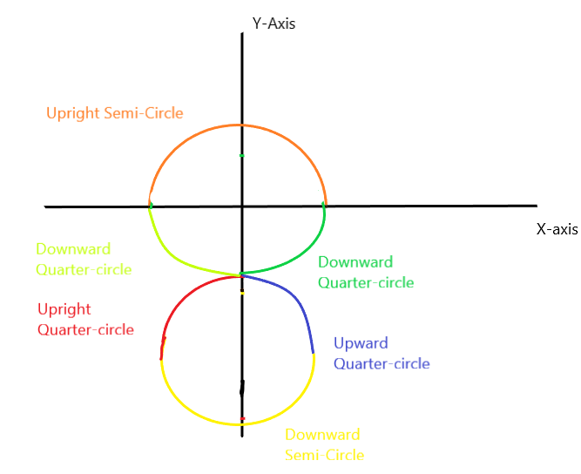
First, it creates an upright semi-circle and saves the coordinates in coords1 taking origin (0, 0) as centre(in latitude and longitude, it is the home location)

Second, from previous end point it creates a downward quarter-circle and saves the coordinates in coords2.

Third, from previous end point it creates an upright quarter-circle taking (0, 2*RADIUS) (because of error in calculation, the centre coordinate is (0, 2.32*RADIUS) instead) as centre and saves the coordinates in coords3.

Fourth, from previous end point it creates a downward semi-circle taking the new centre and saves the coordinates in coords4.

Fifth, from previous end point it creates an upright quarter circle and saves the coordinates in coords5.

Sixth, from previous end point it creates a downward quarter circle taking (0,0) as centre and saving the coordinates in coords6.

- Now converting those cartesian coordinates (x, y) into (latitude, longitude) by using the below transformation.

$New Longitude=Home Longitude+x*\frac{180}{π*Earth Radius*coscos (Home Longitude*\frac{π}{180}) }$

$New Latitude=Home Latitude+y*\frac{180}{π*Earth Radius}$
And returning them.
- In the function adds_horizontal_eight_mission(), calling the get_horizontal_eight_points() and then feeding those points in simple_goto() function for vehicle 2.

VERTICAL MISSION
- The function, get_vertical_eight_points() does the the same job as get_horizontal_eight_points() but in vertical condition I have taken latitude same and varied longitude accordingly with the altitude.

$New Longitude=Home Longitude+x*\frac{180}{π*Earth Radius*coscos (Home Longitude*\frac{π}{180}) }$

$New Latitude=Home Latitude$

$New Altitude=y+ Home altitude$
Now transforming cartesian coordinate x into longitude using above transformation.
This time the y coordinates are not transformed into latitude rather they are summed up to the takeoff/home altitude and then returned.
(Taking appropriate home altitude such that drone/quad dose not hit ground when doing mission)

- The function adds_vertical_eight_mission() calls the get_vertical_eight_points() and then adding latitude and longitudes this time altitudes also into waypoint commands. And creating the mission for vehicle 1.

HORIZONTAL MISSION
- The function get_horizontal_circle_points() solves the equation of circle x^2 + y^2 = r^2 and saves it in coords list.

First, it creates an upright semi-circle and saves the coordinates in coords1 taking origin (0, 0) as centre(in latitude and longitude, it is the home location)

Second, it creates a downward semi-circle and saves the coordinates in coords2 taking origin (0, 0) as centre(in latitude and longitude, it is the home location)

- Now converting those cartesian coordinates (x, y) into (latitude, longitude) by using the below transformation.

$New Longitude=Home Longitude+x*\frac{180}{π*Earth Radius*coscos (Home Longitude*\frac{π}{180}) }$

$New Latitude=Home Latitude+y*\frac{180}{π*Earth Radius}$
And returning them.
- In the function adds_horizontal_circle_mission(), calling the get_horizontal_circle_points() and then feeding those points in simple_goto() function for vehicle 2.

VERTICAL CIRCLE MISSION
- The function, get_vertical_circle_points() solves the equation of circle x^2 + y^2 = r^2 and saves it in coords list.

$New Longitude=Home Longitude+x*\frac{180}{π*Earth Radius*coscos (Home Longitude*\frac{π}{180}) }$

$New Latitude=Home Latitude$

$New Altitude=y+ Home altitude$

but in vertical condition I have taken latitude same and varied longitude accordingly with the altitude.
Now converting cartesian coordinate x into longitude, using above transformation.
This time the y coordinates are not transformed rather they are summed up with the takeoff/home altitude and then returned.
(Taking appropriate home altitude such that drone/quad dose not hit ground when doing mission)

- The function adds_vertical_circle_mission() calls the get_vertical_circle_points() and then adding latitude and longitudes this time altitudes also into waypoint commands. And creating the mission for vehicle 1.

TRIANGLE MISSION
- The function, get_triangle_points() calculates position of other two drones with respect to the first drone in cartesian system. 1st follower takes the lower edge position of triangle and 2nd follower takes the upper edge position of triangle.

- Then those coordinates (x, y) are transformed into (latitude, longitude) using below transformation.
$New Longitude=Home Longitude+x*\frac{180}{π*Earth Radius*coscos (Home Longitude*\frac{π}{180}) }$

$New Latitude=Home Latitude+y*\frac{180}{π*Earth Radius}$

- The function adds_triangle_mission() calls the get_triangle_points() and then feeds those points into simple_goto() function of every vehicle.

HORIZONTAL LINE MISSION
- The function, get_line_points() calculates position of first two drones i.e., the Leader and 1st follower keeping the 2nd follower at its place, in cartesian system. Then those coordinates (x, y) are transformed into (latitude, longitude) using below transformation.
$New Longitude=Home Longitude+x*\frac{180}{π*Earth Radius*coscos (Home Longitude*\frac{π}{180}) }$

$New Latitude=Home Latitude+y*\frac{180}{π*Earth Radius}$

- The function adds_line_mission() calls the get_line_points() and then feeds those points into simple_goto() function of vehicle 1 and vehicle 2.
L MISSION
- The function, get_L_points() calculates position of Leader i.e.,
vehicle 1, in cartesian system. Then those coordinates (x, y) are transformed into (latitude, longitude) using below transformation.
$New Longitude=Home Longitude+x*\frac{180}{π*Earth Radius*coscos (Home Longitude*\frac{π}{180}) }$

$New Latitude=Home Latitude+y*\frac{180}{π*Earth Radius}$

- The function adds_L_mission() calls the get_L_points() and then feeds those points into simple_goto() function for Leader.

VERTICAL LINE MISSION
- The function, get_vertical_line_points() calculates position of vehicle 2 and vehicle 3 and also changing their altitudes, with respect to the Leader in cartesian system. Then those coordinates (x, y) are transformed into (latitude, longitude) using below transformation.
$New Longitude=Home Longitude+x*\frac{180}{π*Earth Radius*coscos (Home Longitude*\frac{π}{180}) }$

$New Latitude=Home Latitude+y*\frac{180}{π*Earth Radius}$

- The function adds_vertical_line_mission() calls the get_vertical_line_points() and then feeds those points into simple_goto() function for vehicle 2 and vehicle 3.

